Eyelash Extension Client Plan

Client Name: ______________________________________

What type of lashes is the client requesting? __________________________________________________________________

Lash Strength (circle all that apply): brittle thin thick strong

Lash Length in Center (measure): 8 9 10 11 12 13 14

Lash Volume (circle all that apply): sparse normal thick

Choose eye shape (may be more than 1):

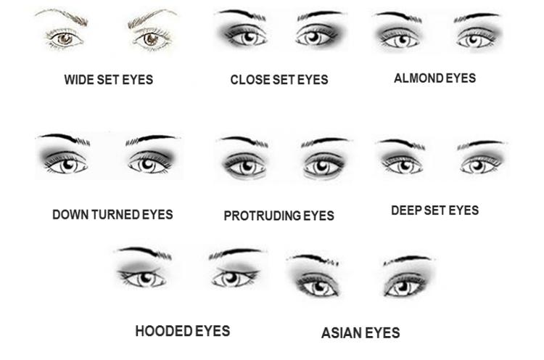

ROUND EYES

Standard Eyelash Plan

Wide Set Eyes
Illusion eyes looking closer together
inner corners C curl, middle D curl, outer C curl

Close Set Eyes
illusion of eyes looking farther apart
cat eye is best. J inner, C middle, D outer

Almond Eyes
“perfect” eye shape
longer on ends or longer in middle will work for this shape depending on size of eye

Downturned Eyes
create illusion of outer corners lifted
cat eye is best. J inner, C middle, D outer

Protruding Eyes
create illusion of eyes setting back a bit more
Use L or D lashes to create darkness along the eyelid

Deep Set Eyes
create illusion of eyes being more forward
Use J on inner corners and C on rest

Hooded Eyes
give more lid space
Use J on inner corners and C on the rest

Monolid Eyes
open up eyes and create lid illusion
Use L curl and longest in the middle

Round Eyes
you can see a little of the white part of the eye below the iris
Keep lashes not too long and slightly longer on the ends
inner, J or C, middle C, ends C or D

